**IN498 Unit 5 Laurence Burden**

**Plots**

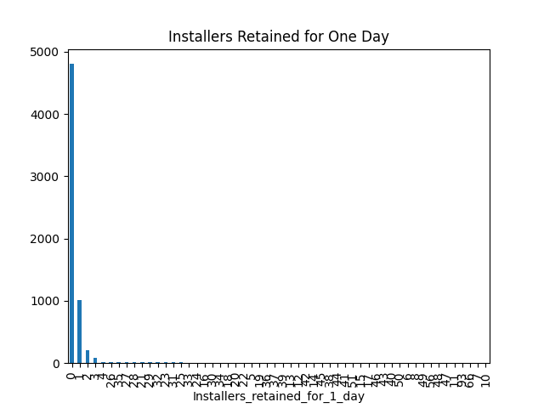

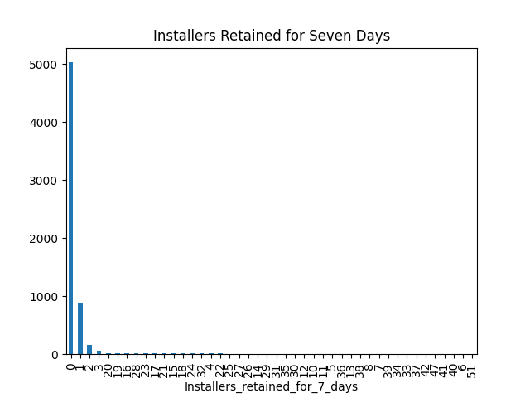

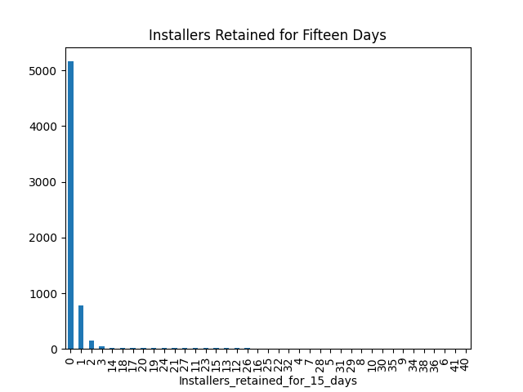

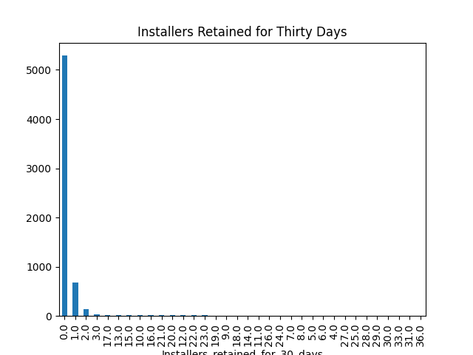

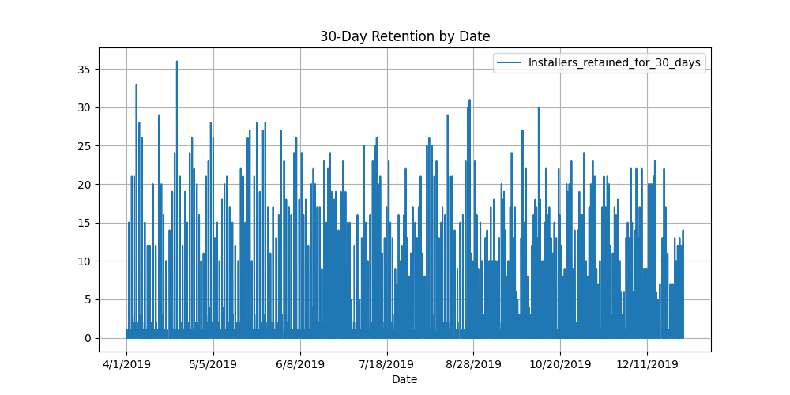

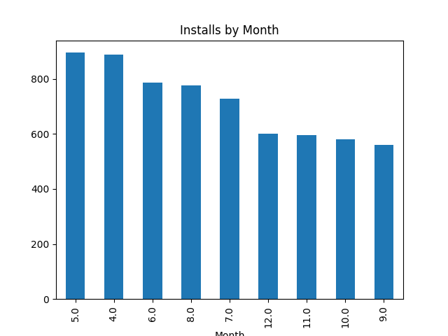

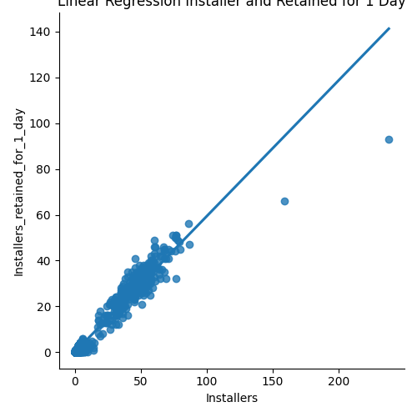

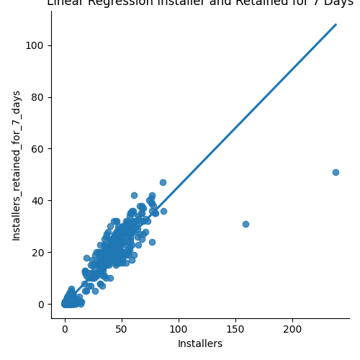

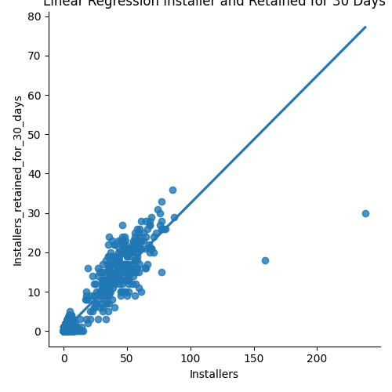

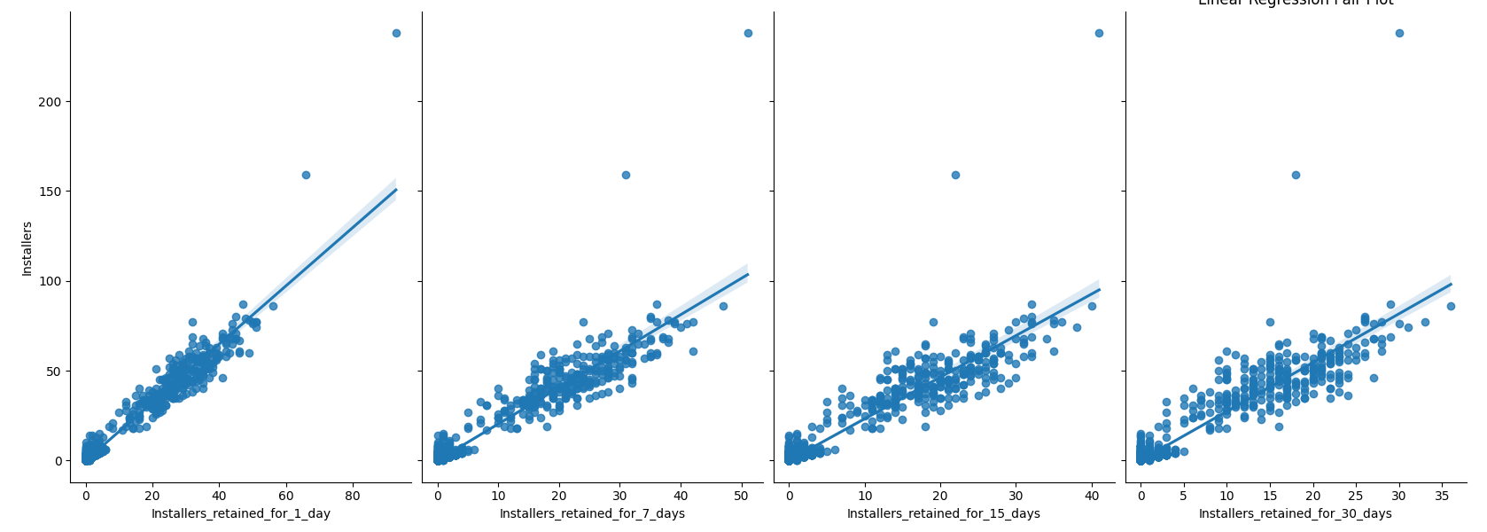

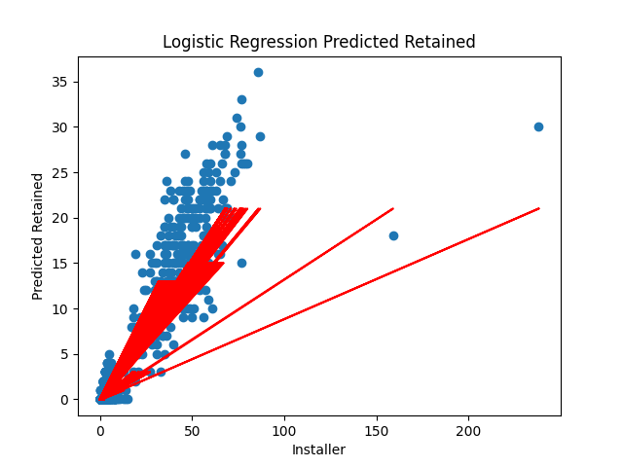

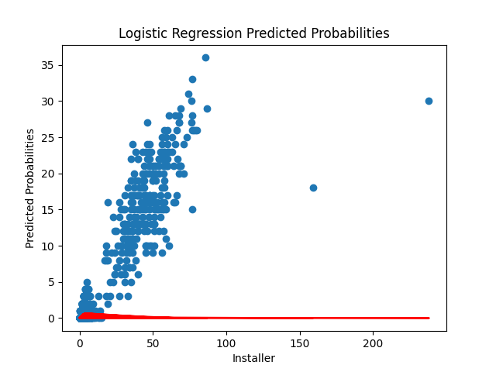

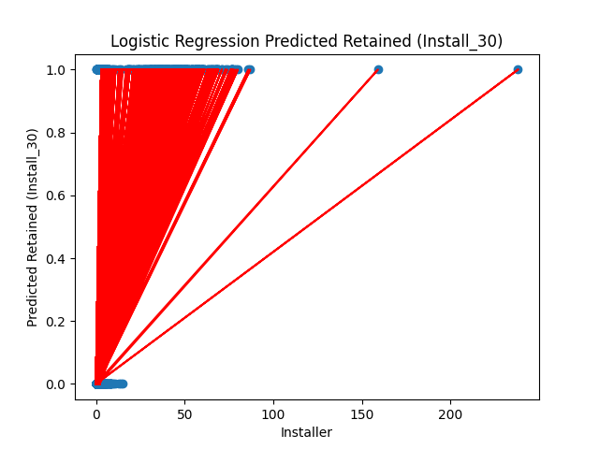

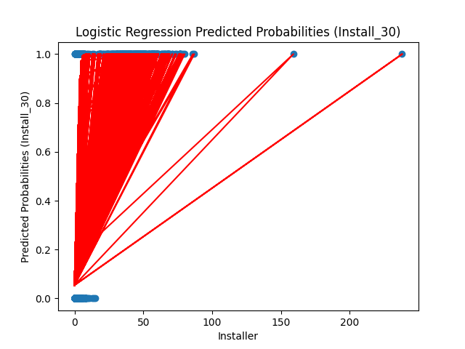

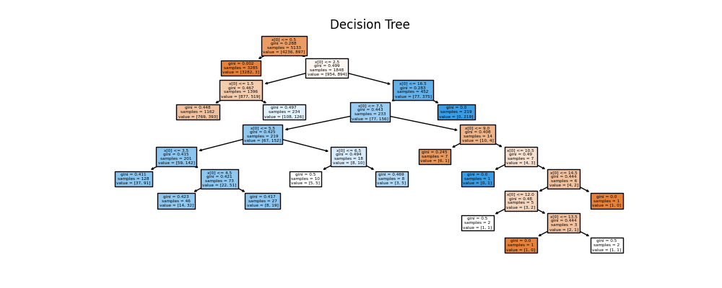

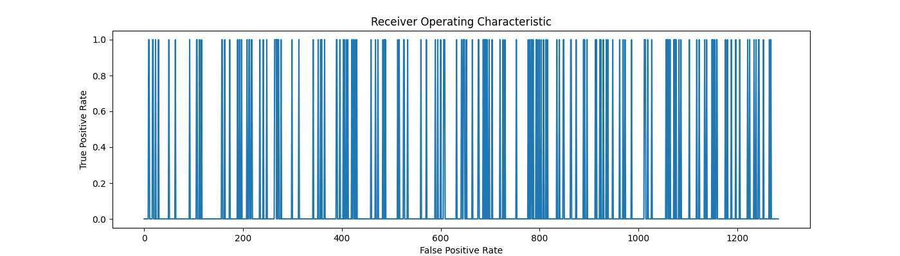

**Code**

import pandas as pd  
import numpy as np  
import seaborn  
from sklearn.linear_model import LinearRegression  
from sklearn.linear_model import LogisticRegression  
from sklearn.tree import DecisionTreeClassifier  
from sklearn.ensemble import RandomForestClassifier  
from sklearn.model_selection import train_test_split  
from sklearn.metrics import roc_auc_score  
from sklearn import metrics  
import sys  
import seaborn as sns  
import matplotlib.pyplot as plt  
from sklearn import tree  
  
# Ignoring warnings  
if not sys.warnoptions:  
 import warnings  
  
 warnings.simplefilter("ignore")  
  
# Widen the column display  
pd.set_option('max_colwidth', 500)  
  
# Read data into a DataFrame using these columns  
# "Date","Package_Name","Country","Store_Listing_Visitors",  
# "Installers","Visitor-to-Installer_conversion_rate",  
# "Installers_retained_for_1_day","Installer-to-1_day_retention_rate",  
# "Installers_retained_for_7_days","Installer-to-7_days_retention_rate",  
# "Installers_retained_for_15_days","Installer-to-15_days_retention_rate",  
# "Installers_retained_for_30_days","Installer-to-30_days_retention_rate"  
col_names = ["Date", "Package_Name", "Country", "Store_Listing_Visitors", "Installers",  
 "Visitor-to-Installer_conversion_rate", "Installers_retained_for_1_day",  
 "Installer-to-1_day_retention_rate", "Installers_retained_for_7_days",  
 "Installer-to-7_days_retention_rate", "Installers_retained_for_15_days",  
 "Installer-to-15_days_retention_rate", "Installers_retained_for_30_days",  
 "Installer-to-30_days_retention_rate"]  
data = pd.read_csv('retained_installers_com.foo.bar_Combined.csv', names=col_names)  
  
########### EXPLORE THE ORIGINAL DATA SET #######################  
# sns.barplot(data['Installers_retained_for_1_day'].value_counts())  
data['Installers_retained_for_1_day'].value_counts().plot(title='Installers Retained for One Day',  
 kind='bar')  
plt.show()  
  
# Plot the installer retention rates for 7 days using a bar chart  
data['Installers_retained_for_7_days'].value_counts().plot(title='Installers Retained for Seven Days',  
 kind='bar')  
plt.show()  
  
# Plot the installer retention rates for 15 days using a bar chart  
data['Installers_retained_for_15_days'].value_counts().plot(title='Installers Retained for Fifteen Days',  
 kind='bar')  
plt.show()  
  
# Plot the installer retention rates for 30 days using a bar chart  
data['Installers_retained_for_30_days'].value_counts().plot(title='Installers Retained for Thirty Days',  
 kind='bar')  
plt.show()  
  
# Plot the retention of users at 30 days per date using a line chart  
# data['Installers_retained_for_30_days'].value_counts().plot(title='Installers Retained for Thirty Days',  
# kind='line')  
data.plot(x='Date', y='Installers_retained_for_30_days', figsize=(10, 5), grid=True)  
plt.title('30-Day Retention by Date')  
plt.show()  
  
# Add a month column by converting the Date column for month only  
data['Month'] = pd.DatetimeIndex(data['Date']).month  
  
# Plot the installs per month using a bar chart  
data['Month'].value_counts().plot(title='Installs by Month', kind='bar')  
plt.show()  
  
########### EARLY SEABORN PLOTS #######################  
# Seaborn simple regression plot of installers retained for 1 day  
sns.lmplot(x='Installers', y='Installers_retained_for_1_day', data=data, ci=None)  
plt.title('Linear Regression Installer and Retained for 1 Day')  
plt.show()  
  
# Seaborn simple regression plot of installers retained for 7 day  
sns.lmplot(x='Installers', y='Installers_retained_for_7_days', data=data, ci=None)  
plt.title('Linear Regression Installer and Retained for 7 Days')  
plt.show()  
  
# Seaborn simple regression plot of installers retained for 30 day  
sns.lmplot(x='Installers', y='Installers_retained_for_30_days', data=data, ci=None)  
plt.title('Linear Regression Installer and Retained for 30 Days')  
plt.show()  
  
############ FIX MISSING DATA #######################  
# Replace NaN with 0 for Installers_retained_for_30_days  
data[np.isnan(data.Installers_retained_for_30_days)] = 0  
  
############ SEABORN PLOT AFTER FIXING MISSING DATA #######################  
# Seaborn pairplot for installers retained for 1, 7, 15, and 30 days  
sns.pairplot(data,  
 x_vars=['Installers_retained_for_1_day', 'Installers_retained_for_7_days',  
 'Installers_retained_for_15_days', 'Installers_retained_for_30_days'],  
 y_vars='Installers', size=6, aspect=0.7, kind='reg')  
plt.title('Linear Regression Pair Plot')  
plt.show()  
  
########### LOGISTIC REGRESSION #######################  
# Get logistic regression model  
logreg = LogisticRegression()  
  
# Set feature_cols to Installers column data only  
feature_cols = ['Installers']  
  
# Set X to feature_cols  
X = data[feature_cols]  
  
# Set y to installer retained for 30 days  
y = data.Installers_retained_for_30_days  
  
# Fit X and y to logistic regression model  
logreg.fit(X, y)  
  
# Predict classes using X and save as a variable called assorted_pred_class  
assorted_pred_class = logreg.predict(X)  
  
# Plot the predictions in a scatter plot using  
# Scatter uses data.Installers and data.Installers_retained_for_30_days  
# X label of Installer  
# y label of predicted retained  
# Plot using data.Installer and the prediction results (assorted_pred_class) on X  
plt.scatter(data.Installers, data.Installers_retained_for_30_days)  
plt.plot(data.Installers, assorted_pred_class, color='red')  
plt.xlabel('Installer')  
plt.ylabel('Predicted Retained')  
plt.title('Logistic Regression Predicted Retained')  
plt.show()  
  
# Get the predicted probabilites of class 1  
# Save as a variable called assorted_pred_prob  
assorted_pred_prob = logreg.predict_proba(X)[:, 1]  
  
# Scatter plot the predicted probabilities  
# Scatter uses data.Installers and data.Installers_retained_for_30_days  
# X label of Installer  
# y label of predicted probabilities  
# Plot using data.Installer and the probability results (assorted_pred_prob) on X  
plt.scatter(data.Installers, data.Installers_retained_for_30_days)  
plt.plot(data.Installers, assorted_pred_prob, color='red')  
plt.xlabel('Installer')  
plt.ylabel('Predicted Probabilities')  
plt.title('Logistic Regression Predicted Probabilities')  
plt.show()  
  
#################################### INSTALL_30 ##########################################  
# Add a new column for installers retained for 30 days  
# Call the new column Install_30.  
# If greater than 0, put 1, if 0, put 0  
data['Install_30'] = np.where(data['Installers_retained_for_30_days'] > 0, 1, 0)  
  
########### LOGISTIC REGRESSION #######################  
  
# Perform logistic regression using Install_30 column for y  
# X = Installers column  
logreg = LogisticRegression()  
feature_cols = ['Installers']  
X = data[feature_cols]  
y = data.Install_30  
  
# Fit X and y for logistic regression  
logreg.fit(X, y)  
  
# Predict on X and capture the result to assorted_pred_class  
assorted_pred_class = logreg.predict(X)  
  
# Plot the class predictions  
# Scatter uses data.Intsallers and data.Install_30  
# Plot uses data.Installers and assorted_pred_class  
# X label is Installer  
# Y label is Predicted Retained (Install_30)  
plt.scatter(data.Installers, data.Install_30)  
plt.plot(data.Installers, assorted_pred_class, color='red')  
plt.xlabel('Installer')  
plt.ylabel('Predicted Retained (Install_30)')  
plt.title('Logistic Regression Predicted Retained (Install_30)')  
plt.show()  
  
# Get the predicted probabilites of class 1 and save to assorted_pred_prob  
assorted_pred_prob = logreg.predict_proba(X)[:, 1]  
  
# Plot the predicted probabilities  
# Scatter uses data.Intsallers and data.Install_30  
# Plot uses data.Installers and assorted_pred_prob  
# X label is Installer  
# Y label is Predicted Probabilities (Install_30)  
plt.scatter(data.Installers, data.Install_30)  
plt.plot(data.Installers, assorted_pred_prob, color='red')  
plt.xlabel('Installer')  
plt.ylabel('Predicted Probabilities (Install_30)')  
plt.title('Logistic Regression Predicted Probabilities (Install_30)')  
plt.show()  
  
########### DECISION TREE #######################  
# Train/test split 80% train, 20% test  
X_train, X_test, y_train, y_test = train_test_split(X, y, test_size=0.2)  
  
# Build a decision tree model  
dt = DecisionTreeClassifier(random_state=1)  
  
# Fit the tree using X_train and y_train  
dt.fit(X_train, y_train)  
  
# Plot the decision tree  
plt.figure(figsize=(10,4))  
tree.plot_tree(dt, filled=True)  
plt.title('Decision Tree')  
plt.show()  
  
print(tree.export_text(dt))  
  
########### RANDOM FOREST #######################  
# Build a random forest tree model  
# n_estimators = 1000  
rf = RandomForestClassifier(n_estimators=1000)  
  
# Fit the random tree model with X_train and y_train  
rf.fit(X_train, y_train)  
  
# Get the predicitons using X_test and save to rf_probs  
rf_probs = rf.predict(X_test)  
  
# Plot the random forest predictions using rf_probs  
plt.figure(figsize=(14,4))  
plt.plot(rf_probs)  
plt.xlabel('False Positive Rate')  
plt.ylabel('True Positive Rate')  
plt.title('Receiver Operating Characteristic')  
plt.show()